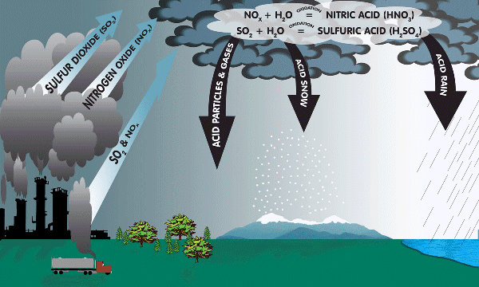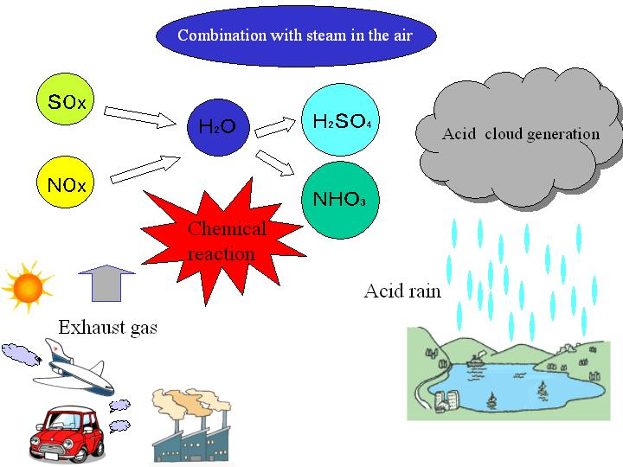

What happens to organisms living in lakes and rivers that are too acidic?

What actions can we take to reduce acid rain?